1. **Transitive Dependency:** Dependency of dependency.   
   **For example**: Spring framework has dependency on other libraries. So identify them, download, add to classpath.  
   But **maven dependency management system** handles that too for us.
2. **Let’s see an example**:
   1. The creator of our archetype has created this very simple unit test.
3. 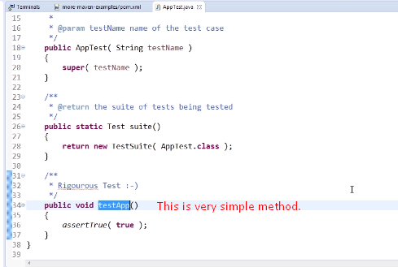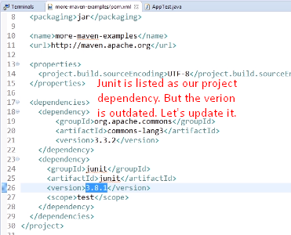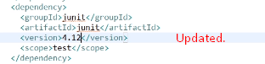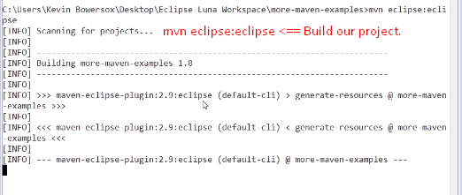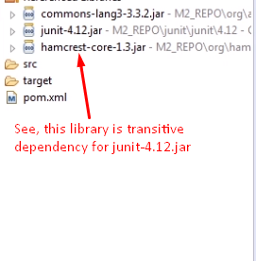  
   Question: How does maven know that JUnit needs **hamcrest-core-1.3.jar** ?
   1. Go to the maven central repo?
   2. 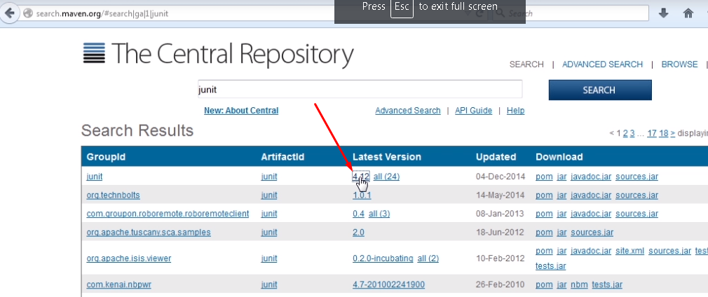
   3. 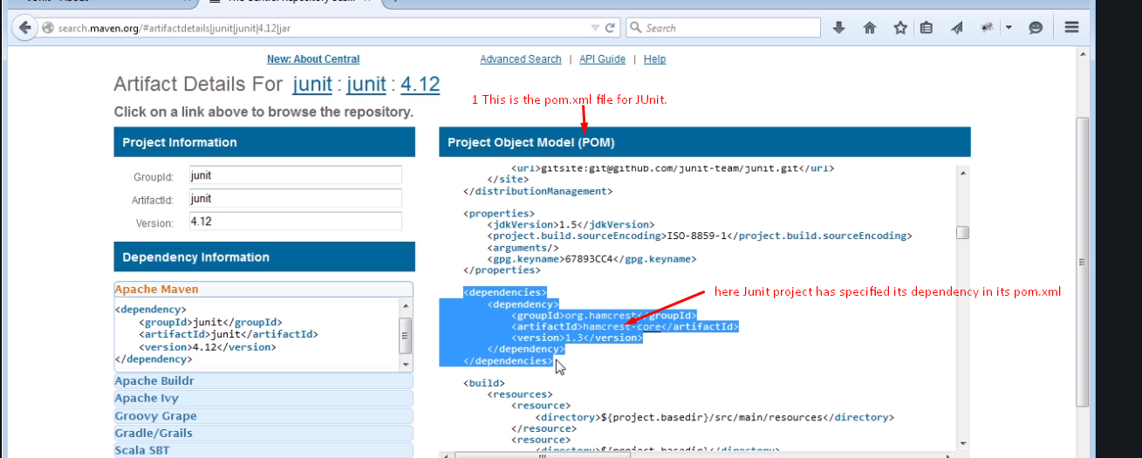
   4. Maven is smart enough to consult junit’s pom.xml file and realizes that we need hamcrest-core.1.3.jar library in order for our application to run its unit tests.  
      It can go an infinite level of dependencies.